CREATING A MINIKUBE SERVICE TO HANDLE CONTAINERS

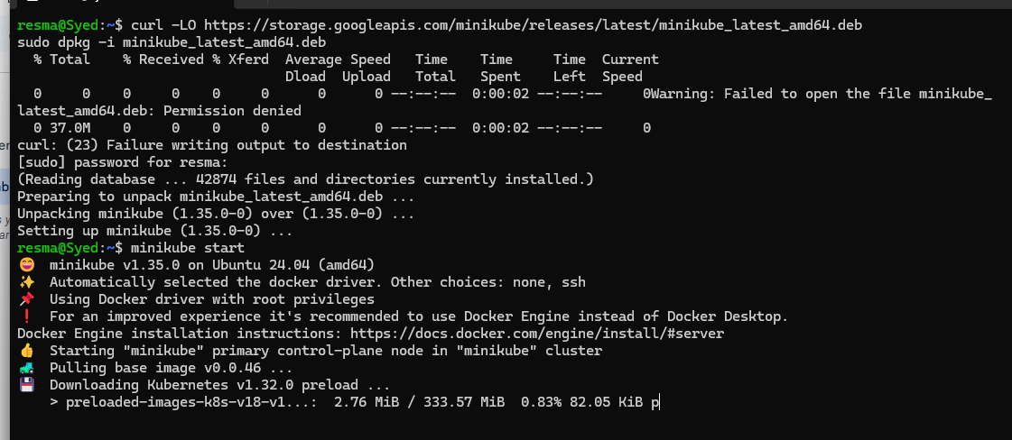

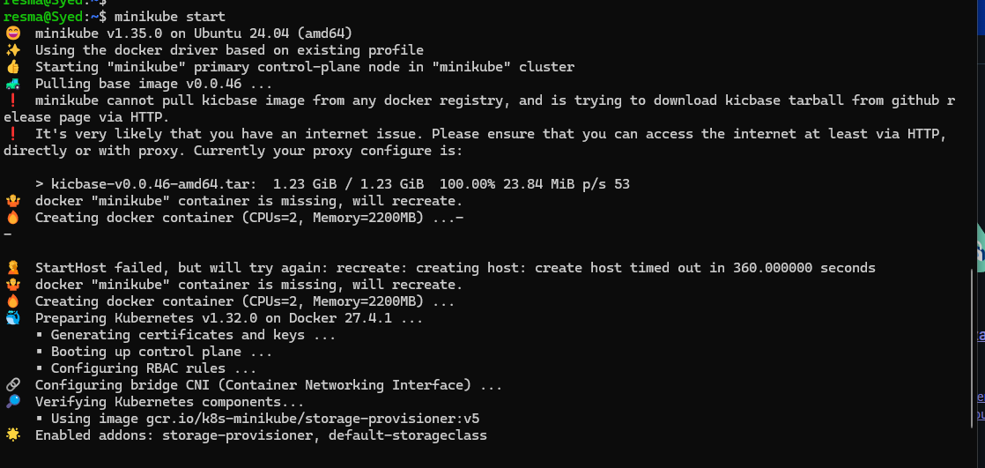

Creating a deployment

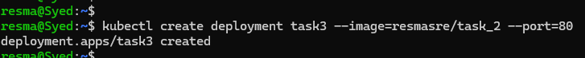

To get the deployments

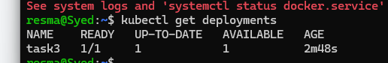

To expose deployment



To get the service

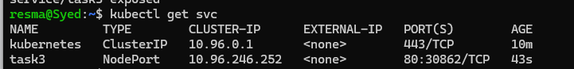

Opening the minikube service

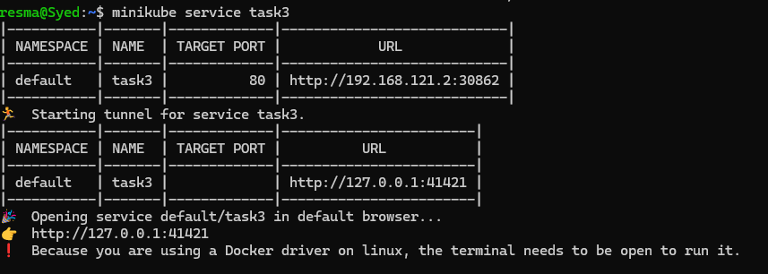

Localhost output

